Topic 10
International conflicts and crises in the 20th century (II) the Cold War and the Post-Cold War period
Name: ___________________ ( ) Class: __________

Key Learning Points
- Causes and the major developments of the Cold War
- End of the Cold War and the international situation in the post-Cold War period
- Case study: Historical figures representing different stages in the Cold War (Choose 1 out of 5) (Extended part)

Timeline of historical events
1945 | End of the Second World War
1946 | Churchill delivered the Iron Curtain Speech.
1948-1949 | Outbreak of the Berlin Blockade
1950-1953 | Korean War
1962 | Outbreak of the Cuban Missile Crisis
1965-1975 | US intervention in the Vietnam War
1969-1979 | The US and the USSR convened 2 rounds of Strategic Arms Limitation Talks.
1979 | Soviet invasion of Afghanistan
1989 | - Collapse of socialist regimes in Eastern Europe  - Fall of the Berlin Wall
1991 | Dissolution of the USSR and the end of the Cold War
2001 | September 11 attacks

I Causes and the major developments of the Cold War
A Definition of the Cold War
- The (a) ___capitalist bloc___ led by the US was in intense rivalry with the socialist bloc led by (b) ___the USSR___ .  - As both sides tried hard to avoid direct military conflicts, this period is known as the (c) ___Cold War___ . | 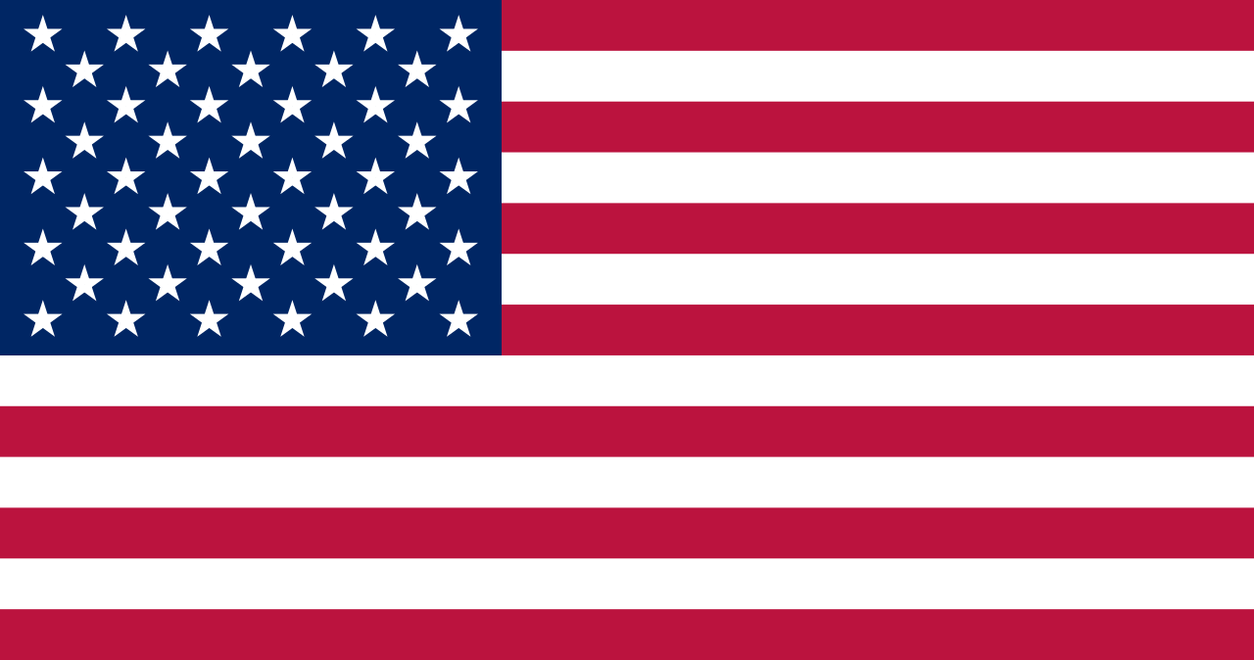
 | 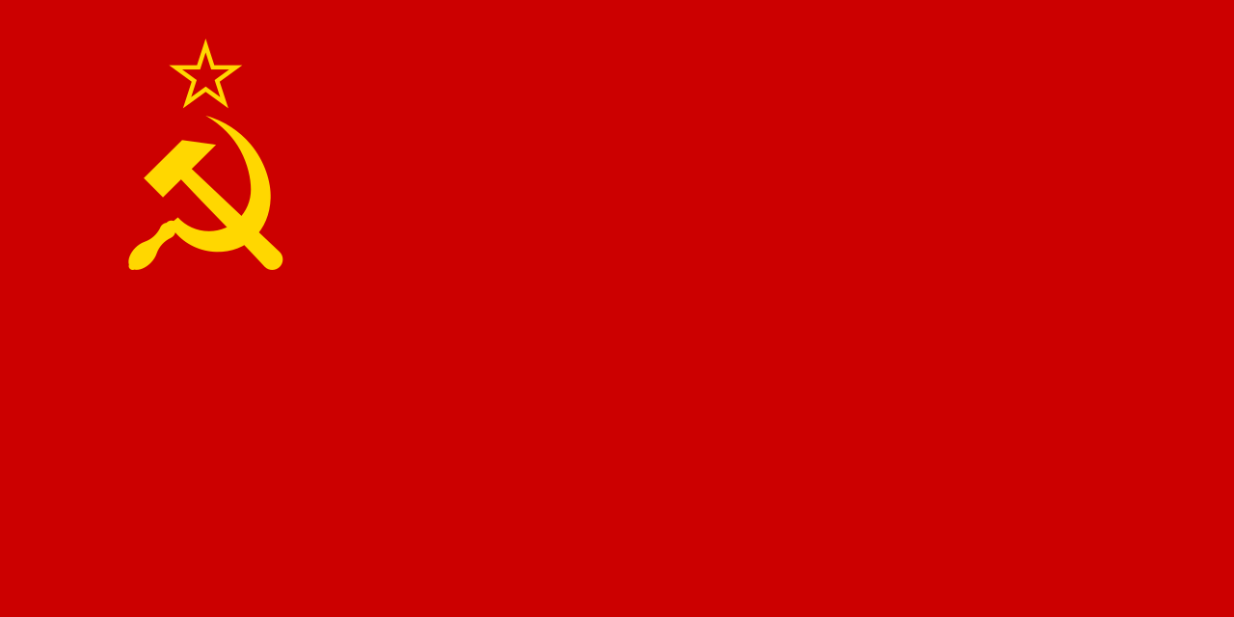
B Fundamental causes of the Cold War
- 以美國為首的 (a) ___資本主義___ 集團，與以 (b) ___蘇聯___ 為首的共產主義集團長期維持對抗的狀態。
- 雙方極力避免直接的軍事衝突，所以稱為 (c) 「___冷戰___ 」。
1. Ideological differences between the US and the USSR
 | Capitalism ( The US) | Communism ( The USSR)
Political aspect | Multi-party democracy | (a) ___One-party rulership___
Economic aspect | - market economy  - (b) ___Private ownership of property___ | - (c) ___Planned economy___  - Public ownership of property
Social aspect | Individualism, emphasising  (d) ___liberty and human rights___ | Collectivism, establishing a classless society
Diplomatic aspect | Containing the spread of communism | Promoting (e) ___world revolution___

2. Long-term distrust between the USSR and 134 Western countries
On the eve of WWII
- Britain and France refused to co-operate with the USSR to resist (f) ___Germany___ .
- The signing of the (g) ___German-Soviet Non-Aggression Pact___ deepened the distrust between the USSR and Western countries.
During WWII
The USSR and Western countries had disagreements over (h) ___post-war arrangements___ .

3. Post-WWII international situation  - Europe faced heavy casualties and destruction. The US and the USSR rose rapidly and became (i) ___superpowers___ .  - They provided aid to European countries to control the local developments, so that they could build a new international order that suited their own interests and (j) ___ideologies___ . | 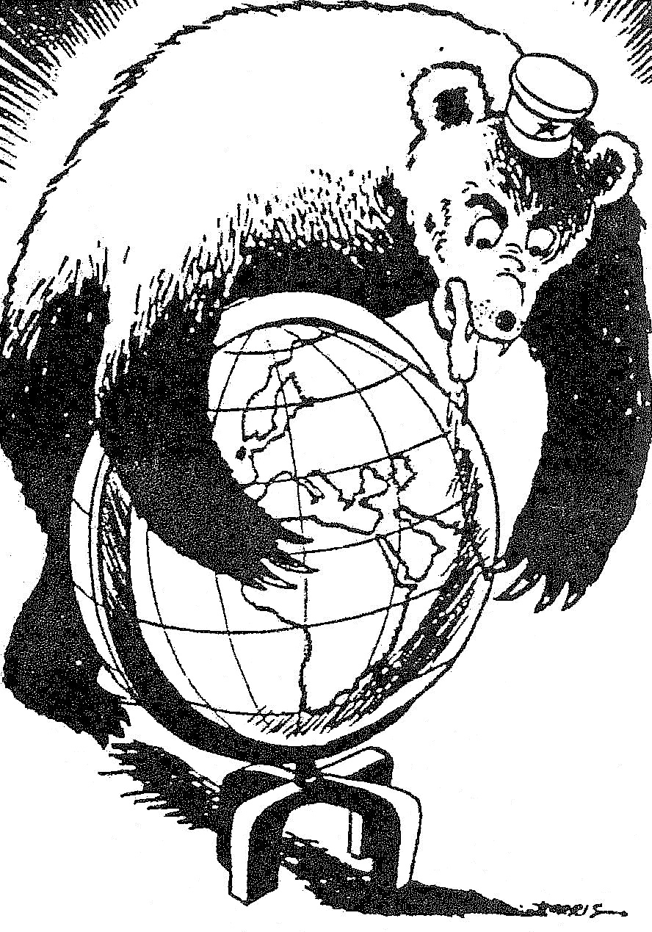  An US cartoon satirising Soviet ambitions
4. Conflicting interests of the US and the USSR
After WWII, the USSR set up several socialist regimes in (k) ___Eastern Europe___ , the US also tried to check the spread of communism by supporting democratic forces in Europe.

C Characteristics of the Cold War
Taking part in  economic rivalry | The US introduced the (a) ___Marshall Plan___ while the USSR introduced the (b) ___Molotov Plan___ , to strengthen the power and cohesion of their own bloc.
Forming opposing  military organisations | The US formed the (c) ___North Atlantic Treaty Organization___ and the USSR formed the (d) ___Warsaw Pact___ .
Participating in arms and space races | The US and the USSR invested a lot of capital to develop  (e) ___nuclear weapons___ and new weapons. This led to arms races.
Competing for the support from neutral parties | Both blocs tried to form allies with neutral parties in Asia, Africa and Latin America and often directly interfered in (f) ___regional conflicts___ .
Competing in propaganda | Both blocs often promoted their own values and attacked those of the other through mass media, such as (g) ___radio___ , newspapers, posters, etc.
Conducting spy activities | The US and the USSR established intelligence organisations such as the (h) ___Central Intelligence Agency___ and the Committee for State Security respectively to collect intelligence.
Reducing all kinds  of exchange | Both blocs reduced or blocked all kinds of exchange in the aspects such as trade and (i) ___culture___ .

D Major developments of the Cold War
Beginning of the Cold War (1945-1953)

Churchill delivered the (a) ___Iron Curtain Speech___ , in which he criticised the USSR for setting up an ‘Iron Curtain’ to impose suppressive control over Eastern Europe.
1946
The Cold War officially began.

The Greek Civil War broke out. US president (b) ___Harry Truman___ announced that the US would provide aid to Greece and Turkey, which is known as the (c) ___Truman Doctrine___ .
The US actively intervened in world affairs and maintained the (d) ___containment___ policy against the USSR.
1947
The economies of Western European countries had returned to pre-WWII level, successfully stopped the spread of (g) ___communism___ in Europe.
The US introduced the (e) ___Marshall Plan___ while the USSR introduced the (f) ___Molotov Plan___ .

Germany was split into the Federal Republic of Germany ( (l) ___West Germany___ ) and the German Democratic Republic ( (m) ___East Germany___ ) .
Outbreak of the Berlin Blockade (1948-1949)
- After WWII, Germany and its capital Berlin were divided into 4
(h) ___occupation zones___ which were controlled by the USSR, the US, Britain and France.
- After the Western zones joined the Marshall Plan, the USSR put a total blockade on (i) ___Berlin___ .
- Britain and (j) ___the US___ launched a large-scale airlift.
- The USSR lifted the (k) ___Berlin Blockade___ in May 1949.
1948
1949
12 Western countries formed the (n) ___North Atlantic Treaty Organization___ (NATO).
The US-Soviet rivalry had risen to military level.
The Communist Party of China defeated the civil war and formed the
(o) ___People's Republic of China ___ .
The Cold War spread from Europe to (p) ___Asia___ .

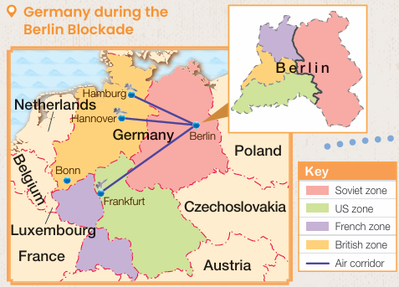 | 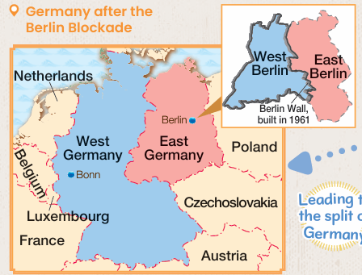
Korean War (1950-1953)
- After WWII, the Korean Peninsula was divided into (q) ___North Korea___ that practised communism and South Korea that practised (r) ___capitalism___ .
- After the outbreak of the Korean War, the United Nations Command, which comprised mainly (s) ___US troops___ was deployed to support South Korea.
(t) ___China___ sent the Chinese People's Volunteer Army to support North Korea.
- In 1953, the two warring sides signed an armistice.
1950
1953
- Since then, North and South Korea have remained divided.
- The US strengthened its military influence around the world.

Spread of the Cold War (1953-1969)

To oppose NATO, the USSR and seven satellite states formed the (a) ___Warsaw Pact___ .
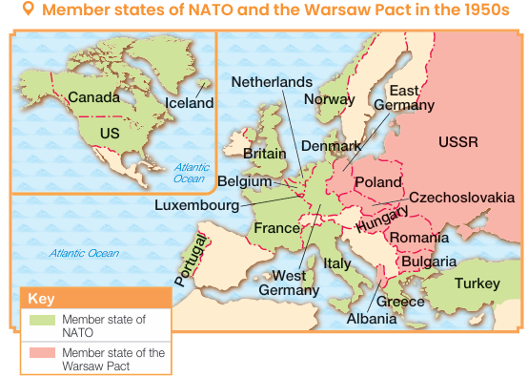
Eastern and Western Europe split into two military camps, intensifying the armaments race.
1955

Happening of the U-2 Incident (1960)
A US (b) ___U-2 spy plane___ was shot down over the USSR. US president Eisenhower refused to apologise to the Soviet leader (c) ___Khrushchev___ .
US-Soviet relations worsened again.
1960

The USSR ordered the East German government to close the border between East and West Berlin and build the (d) ___Berlin Wall___.
US-Soviet relations further worsened.

1961
The Berlin Wall under construction

Outbreak of the Cuban Missile Crisis (1962)
- The US discovered that the USSR was building a missile base in (e) ___Cuba___ . Therefore, the US imposed a (f) ___naval___ blockade.
- The USSR backed down and removed the missiles.
(g) ___Hotline___ was established to allow direct communication between leaders.
1962
Détente

US intervention in the
(h) ___Vietnam War___ (1965-1975)
- After WWII, Vietnam was split into (i) ___North Vietnam___ and South Vietnam.
- In 1965, (j) ___the US___ directly sent troops to assist South Vietnam in the war, but failed to help South Vietnam defeat North Vietnam, which was supported by the USSR and (k) ___China___ .
- (l) ___North Vietnam___ united Vietnam and Vietnam became a socialist country.
- The US paid a heavy price. It gave up the
(m) ___containment___ policy and tried to improve relations with the USSR.
1965

Détente (1969-1979)
Between 1969 and 1979, the US and the USSR held two (a) ___Strategic Arms Limitation Talks___ . They reached agreements on the limitations of strategic weapons, such as nuclear warheads and
(b) ___missile___ systems.
1969
(c) ___Armaments race ___ became less intense. The relations between two countries were improved.

- In 1971, China took back its seat in the
(d) ___United Nations___ .
- In 1972, US president (e) ___Nixon___ visited China.
- In 1979, China and the US established normal diplomatic relations.
1979
The socialist bloc was less united. The USSR began to use tougher measures for strengthening the socialist bloc.

Revival of the Cold War (1979-1985)

The USSR sent troops to (a) ___Afghanistan___ . The US asked the USSR to withdraw its forces, but the USSR ignored this request.
US-Soviet relations fell apart again.
1979

The USSR ordered the Polish government to crack down on (b) ___Solidarity___ by force.
US-Soviet relations worsened further.
1981

US president (c) ___Reagan___ proposed the (d) ___Strategic Defence Initiative___ ), which is also known as ‘Star Wars’.
- Led to a new round of (e) ___arms races___ .
- The Soviet economy became worse over time, the USSR sought to improve relations with the US
1983
The Cold War nearly ended

II End of the Cold War and the international situation in the post-Cold War period
A End of the Cold War(1985-1991)
Introduction of reforms by Gorbachev (1985-1991)
Happening of the (g) ___August Coup___ (August 1991)
Outbreak of democratic movements in Eastern Europe (1988-1990)
Dissolution of the USSR
(December 1991)
Introduced reforms to achieve the aims of (a)‘ ___restructuring___ ’ and (b)‘ ___openness___ .’

Gorbachev actively improved relations with the West. Together with US president (c) ___George H.W. Bush__ , they stated their willingness to end the Cold War.
- Caused serious economic chaos and splits within the Communist Party of the Soviet Union
- (d) ___Soviet republics___ wanted to leave the union, marking the beginning of the collapse of the USSR.
In 1988, the USSR relaxed the Soviet control over Eastern Europe.

CPSU (h) ___conservatives___ staged a coup and failed. Gorbachev could not control the situation and lost much of his influence.

- The Soviet republics announced their independence from the USSR. Most of the former Soviet republics formed the (i) ___Commonwealth of Independent States___ .
- The USSR collapsed.

- (e) ___Multi-party democracies___ were established in Eastern Europe. The Iron Curtain came to an end.
- (f) ___Germany___ was reunited.
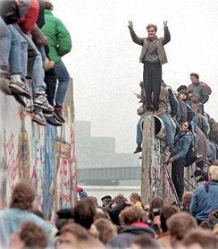
The fall of Berlin Wall

End of the Cold War

B International situation in the post Cold War period
US supremacy
Regional conflicts and crises
Rise of different regional forces and emerging economies
Threat of terrorism
Participating

Arousing dissatisfaction

Targeting at the US

Challenging

1. US supremacy
- Following the end of the Cold War, the US became the only (a) ___superpower___ .
- The US called itself the ‘ (b) ___world's policeman___ ’ and was active in resolving regional conflicts, having huge influence in international affairs.

2. Rise of different regional forces and emerging economies
- After WWII, Western European countries formed various organisations for economic co-operation.
- In 1993, (c) ___European Union___ was formed. Europe’s international influence has been continuously increasing.
European Union

- Since 1978, China adopted the (d) ___Reform and Opening-up___ policy, created an economic miracle that attracted worldwide attention.
- By 2010, China had become the world's (e) ___second___ largest economy, playing a significant role in international affairs.
China

India began to introduce (f) ___economic liberalisation___ reforms in 1991. Its economy has continued to grow rapidly. In 2022, India became the fifth largest economy in the world.
India

3. Regional conflicts and crises
(g) ___Gulf War___  (1990-1991) | The joint forces led by the US stopped (h) ___Iraq___ 's invasion of Kuwait.
Yugoslav Civil War (1991-1999) | - Different (i) ___ethnic groups___ within Yugoslavia wanted independence. The Yugoslav Civil War finally broke out in the 1990s.  - NATO bombed Yugoslavia to stop the (j) ___ethnic cleansing___ there.
Arab-Israeli conflicts (1948-present) | - The conflicts between Israel and the Arabs have remained unsolved.  - The US helped arrange peace talks between them.

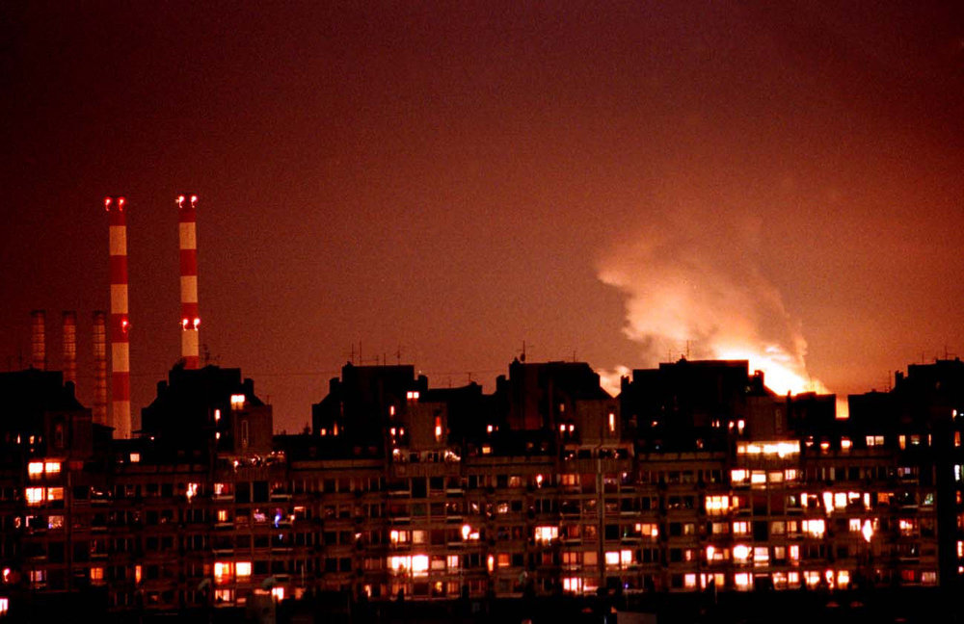  NATO launched air strikes against Serbia. | 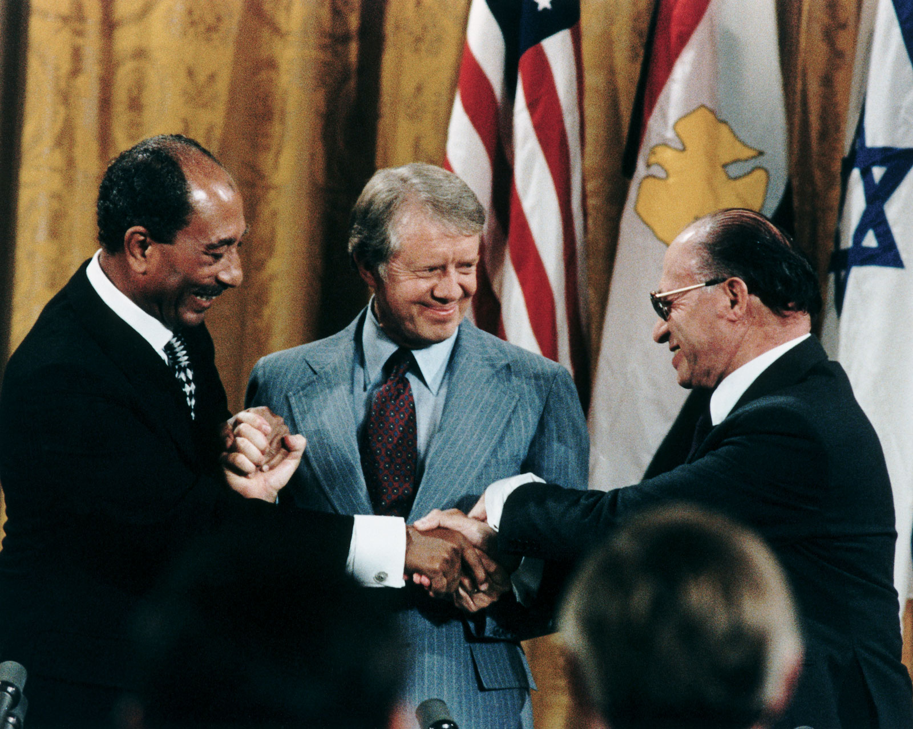  Arranged by the US, Israel and the Arabs signed the first peace agreement, Camp David Accords, in 1978.
4. Threats of terrorism

Terrorism
The use of threat or violence as a means to frighten
(k) ___civilians___ or a government to achieve specific aims.

Development of terrorism  in the post-Cold War period | September 11 attacks
After the end of the Cold War, some  (l) ___extreme groups___ resented (m) ___US___ intervention in other countries' affairs, and they carried out terrorist attacks targeted at the US. | - On 11 September 2001, (n) ___al-Qaeda__ carried out the September 11 attacks.  - The US started a series of (o) ___War on Terror ___ , including theWar in Afghanistan and the (p) ___Iraq War___ .
III Case study: Historical figures representing different stages in the Cold War (Choose 1 out of 5) (Extended part)
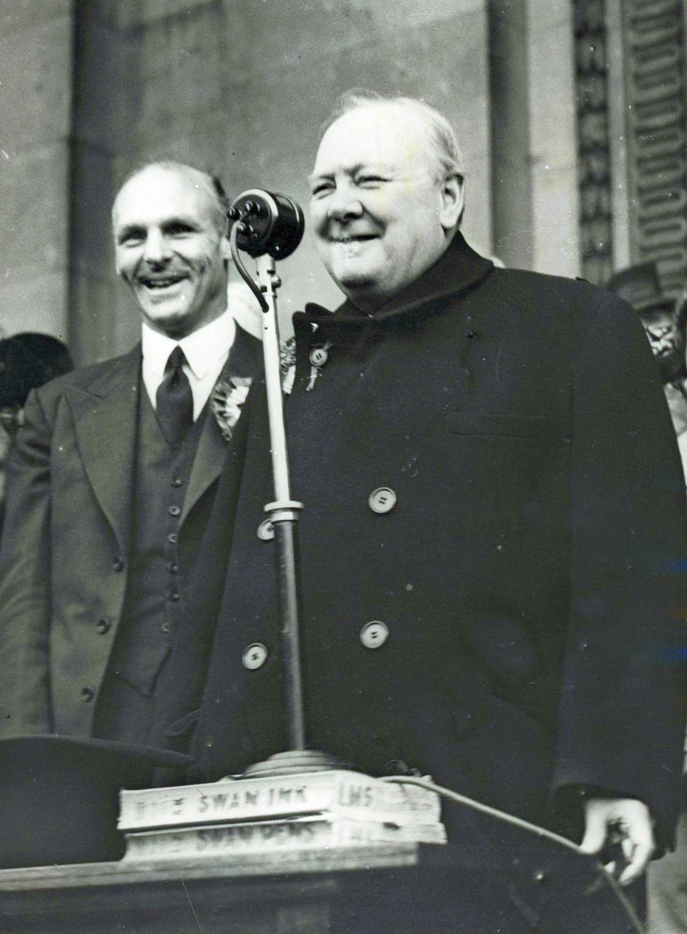  Winston Churchill (1874-1965) | Qualities as a leader
Had the foresight
Devised a blueprint for the (a) ___post-war world___ during WWII.
Spirit of innovation
His idea of creating a (b)‘ ___United States of Europe___ ’ served as a prelude to the present-day European Union.

Qualities as a leader | 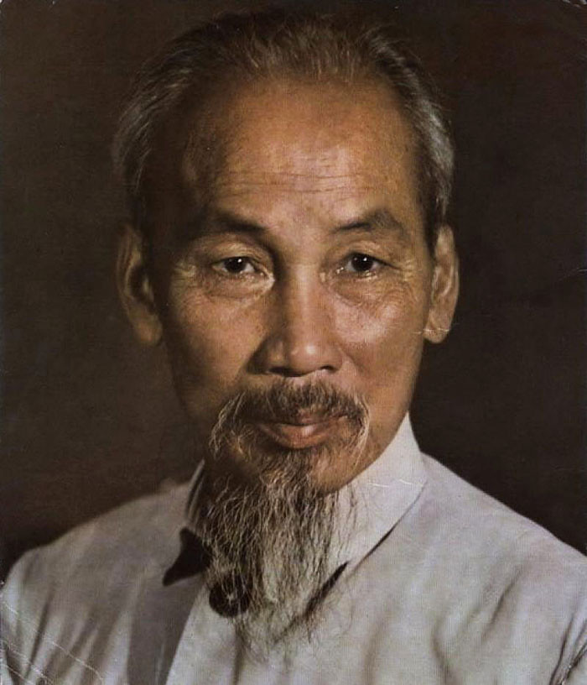  Ho Chi Minh (1890-1969)
Outstanding diplomatic approach,
while upholding the principle of independence and autonomy.
Actively sought aid from the USSR and China in order to resist (c) ___the US___ which had an absolute military advantage over Vietnam.

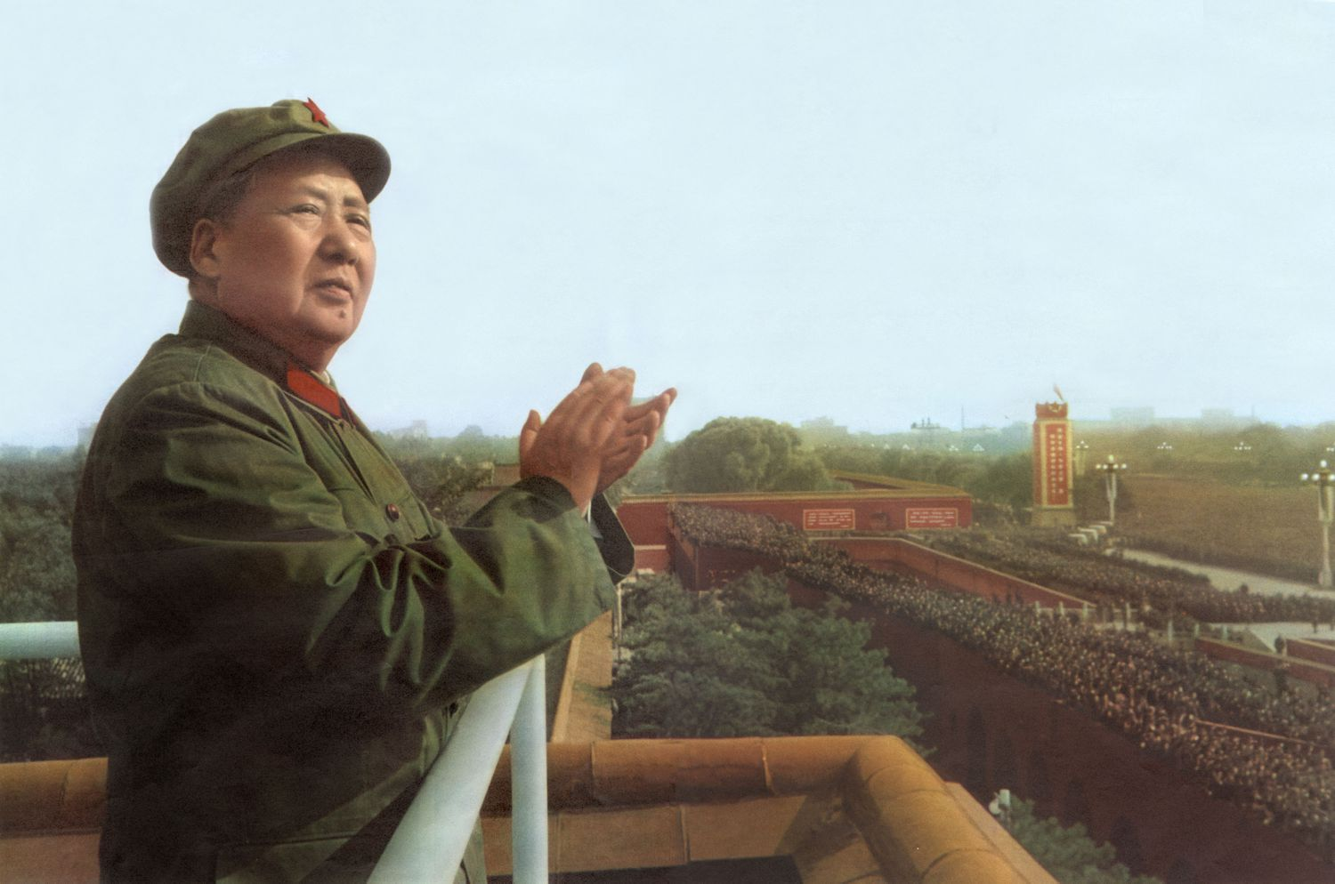  Mao Zedong (1893-1976) | Qualities as a leader
Had an analytical mind
Proposed many governance philosophies since the founding of the People’s Republic of China. (d) ___Mao Zedong Thought___ remains one of the guiding ideologies for the Communist Party of China.
Good at taking stock of the circumstances
When the relations between China and the USSR worsened, Mao Zedong decided that China should follow its own path by developing diplomacy with (e) 「 ___Third World___ countries.

Quality as a leader | 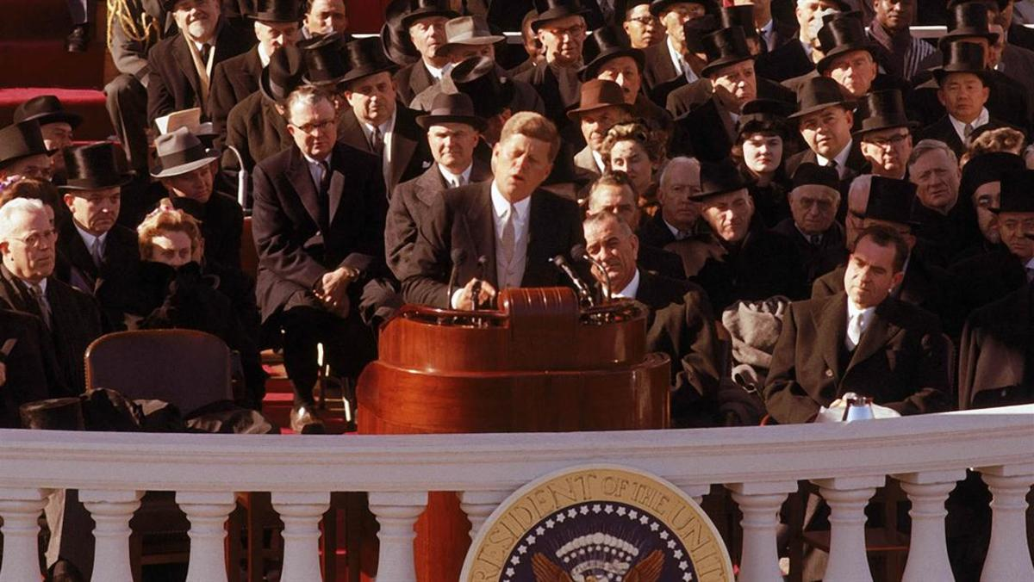  John Kennedy (1917-1963)
Decisiveness
Successfully solved the Cuban Missile Crisis, showing his (f) ___decisiveness___ .

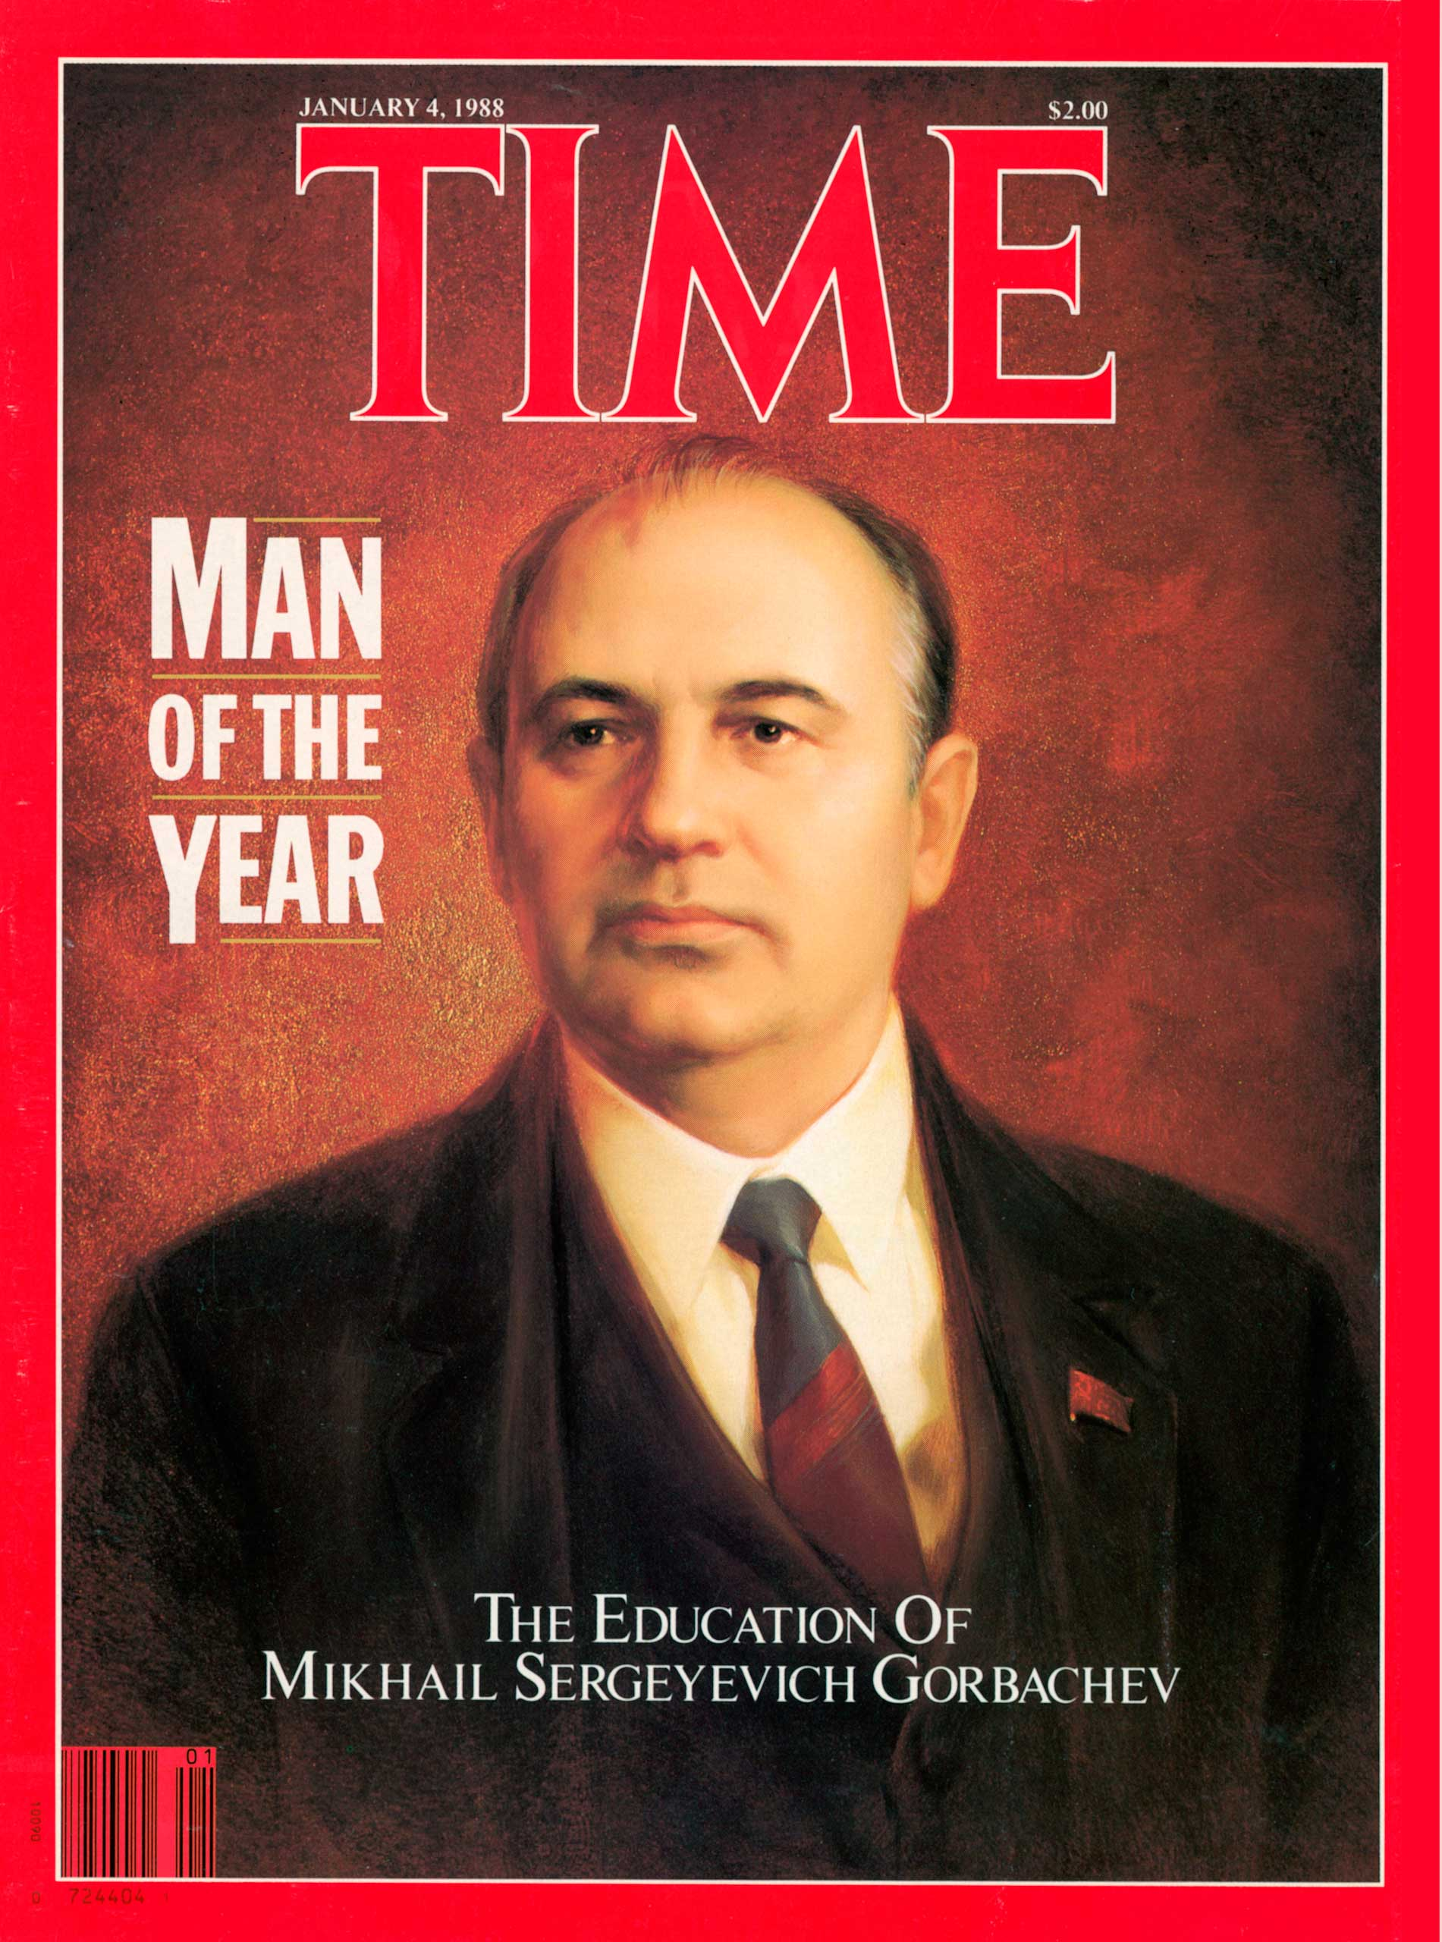  Mikhail Gorbachev (1931-2022) | Qualities as a leader
Courage to be innovative
Introduced radical reforms with great resolve.
Adaptive and decisive
Took the initiative to improve relations with the West.

